Name:___________________________

Stacking and Packing Practical Activity
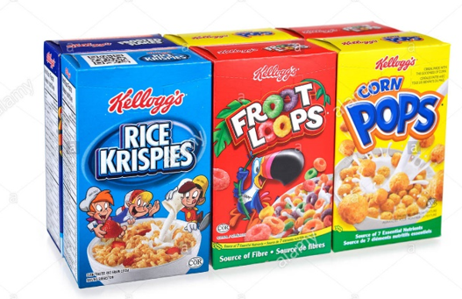
Step 1: Cut out the 4 x 4 x 4cm cube
- Fold along the dotted lines
- Glue and tape to construct the cube
- KEEP the scrap paper to one side of your desk
Step 2: Cut out the 8 x 4 x 2cm rectangular prism
- Fold along the dotted lines
- Glue and tape to construct the prism
- KEEP the scrap paper to one side of your desk
Step 3: Complete the following questions
- Find the surface area of the cube (remember surface area is found by adding the area of all the faces)

- Find the volume of the cube (Volume of a cube = length x width x height)

- Find the surface area of the rectangular prism

- Find the volume of the rectangular prism (Volume of a rectangular prism = length x width x height)

- Write 1-2 sentences about the differences and/or similarities of the volume of the cube and rectangular prism.

- Looking at the left over paper on your desk, what do you notice about the surface area of the rectangular prism and cube. Compare

- Which type of packaging would use the least amount of paper? Look at the leftover paper.

Step 4: In pairs discuss the statement below and be prepared to share your answers in a class discussion.
“Since cube shapes use less materials why don’t breakfast cereal companies sell cereal in this way. Rather cereal boxes are rectangular prisms. Why?”

